1. **INTRODUCTION**

Engineering drawing is a universal language and very important in today’s technological world. From the design phase to the construction phase, Engineering drawings are used to communicate ideas, concepts, and instructions from the drafter to the reader. Drafting is a graphic form of communication that allows people to share their ideas with others regardless of language barriers. Every line and symbol used in engineering drawing has a specific meaning throughout the world. All occupations require the ability to interpret graphic forms of communication.

## THE DRAWING INSTRUMENT.

A draftsperson needs some basic tools to draw. The Drawing kit includes the following instruments:

**(i) Pencil**

Good pencils of reasonable length are essential for producing neat accurate constructions, sketches and drawings. The grade of pencil which should be used depends to a large extend on the quality of the drawing paper available, but as a general recommendation HB and F (medium grade pencils) are suitable for sketching and outlining H and 2H (slightly harder pencils) are suitable for producing geometrical construction and machine drawings.

Thus B, 2B, 3B… are soft pencil becoming softer as the number prefix ascends

H, 2H, 3H … are hard pencil becoming harder as the number prefix ascends.

**(ii) Drawing papers**

Drawing papers are sized according to ISO “A” series. There prefixed from the largest to the smallest. It is essential that the drawing paper size is observed before using it so as to adhere to the standards.

|  |  |  |
| --- | --- | --- |
| **Description** | **Length** | **Width** |
| A0 | 1188 mm | 841 mm |
| A1 | 840 mm | 594 mm |
| A2 | 594 mm | 420 mm |
| A3 | 420 mm | 297 mm |
| A4 | 297 mm | 210 mm |

**(iii) Compasses:**

A device consisting of two hinged legs for drawing circles, always check that centre screw is both strong and rigid before starting to use the pair of compasses. Lead used in compasses must be the same as those used in pencil.

**(iv) Set of squares**

Set squares are used to construct lines inclined at standard angles (30º, 45º, 60º) there are two types of set are:

1. 45º set squares
2. 60º set squares

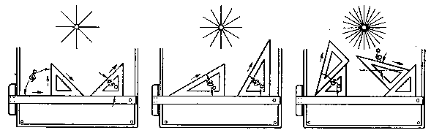

* **Adjustable set square**

There is an adjustable set square this more useful for drawing lines parallel to each other and also for drawing angles.

* **Use and Care**

A set square should be used only while in good condition. They should be discarded immediately as they become bowed, cracked or broken.

**(v) Rule**

A rule should be at least 300 mm long and cleanly marked in mm and multiples of mm (cm). It must be kept clean and in good condition.

**(vi) Drawing board**

A drawing board can be plastic, wood or any other hard material made accurately flat and to the dimensions

* **Tee square**

A tee square used together with drawing board for:

(i) Draw horizontal line on a drawing board.

(ii) To support set squares and other related instruments when used on a drawing board

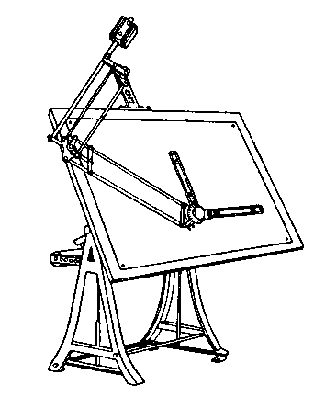

**Drawing table**

**French Curves**

A common set of curves is the Burmester set displayed below. The first item is very handy for ellipses, the second very often fits large parts of hyperbolas and the third (largest) item is used most for parabolas.

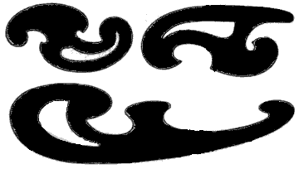

1. **TYPES OF LINE**

TABLE 1.1

|  |  |  |
| --- | --- | --- |
| **LINE** | **DESCRIPTION** | **GENERAL APPLICATIONS** |
| **A** | Continuous thick | Al Visible outlines  A2 Visible edges |
| B | Continuous thin  (straight or curved) | B1 Imaginary lines of intersection  B2 Dimension lines  B3 Projection lines  B4 Leader lines  B5 Outlines of revolved sections in place  B6 Short centre lines |
| **BB** | Continuous thin and feint | BB1 Construction lines  BB2 Guidelines |
| C **D** | Continuous thin freehand  Continuous thin (straight) with zigzags | C1 Limits of partial or interrupted views and sections, if the limit is not a chain line  D1 Break line |
| E **F** | Dashed thick  Dashed thin | E1 Hidden outlines  E2 Hidden edges  F1 Hidden outlines  F2 Hidden edges |
| **G** | Chain thin | G1 Centre lines  G2 Lines of symmetry  G3 Trajectories |
| H | Chain thin, thick at ends and changes of direction | H1 Cutting planes |
| J | Chain thick | J1 Indication of lines or surfaces to which a special requirement applies |
| K | Chain thin double dashed | K1 Outlines of adjacent parts  K2 Alternative and extreme positions of movable parts  K3 Initial outlines prior to forming  K4 Parts situated in front of the cutting plane |

**4.0 LETTERING**

Lettering in engineering drawing is an art of writing on a standard drawing paper. Therefore it is necessary and outmost importance that the draughtsman learns and always practices to write appropriately and accurately on the drawing paper.

Notes may be written both in capital letters or lower case letters and the style of writing can be either vertical or slanted letters.

The essential features of lettering on engineering drawings are legibility, uniformity and the ability to be produced rapidly. The following notes on lettering technique should be observed.

**i. Lettering stroke**

Use single stroke characters devoid of flourishes and ornament. All strokes should be black and of consistent density and uniform thickness.

**ii. Lettering style**

A character of vertical style is suitable for general use and students are recommended to use this style.

**iii. Letter spacing**

Allow a space between characters of twice the line width and six times the line width between words.

**iv. Line spacing**

The space between lines of letters should not be less than 30% of the character height.

**v. Underlining**

Should not be underlined; Use larger characters to emphasize those important notes.

**vi. Letter height**

Recommended height: 1.8, 2.5, 3.5, 5, 7, 10, 14, 20 mm (for drawing practice, use 7 mm for drawing title, 3.5 mm for notes, dimensions etc.)

**vii. Lettering practice**

Lettering should be produced freehand and drawn between a pair of faint guide lines to ensure uniformity. Characters must touch the guide lines and be consistent in width.



**5. TITLE BLOCK**

This standard is specifically applicable for technical drawings in education practice.

**Title block**

There should be provision to mention the following data in the title block

* + - name of the college (or the firm)
    - name of the Department
    - number of the drawing
    - format of the drawing
    - scale used
    - dimensioning unit (usually mm)
    - symbol for method of projection
    - date on which the drawing has been finished
    - name of the draughtsman
    - group and / or registration number
    - name of person who checked the drawing
    - remarks

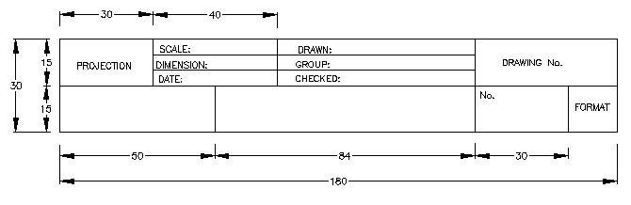

# **6.0 BASIC GEOMETRICAL CONSTUCTIONS OF THE PLANE FIGURE**

The plane figure is the geometry of figures that are two- dimensional, i.e. figures that have only length and breadth and solid geometry is the geometry of three-dimensional figures.

There are an endless number of plane figures but we will concern only in common ones that Triangle, The quadrilateral and polygons. Before we look at any particular figure, there are a few constructions that must be revised.

# 

# *Figure 6.1*To construct a parallel line

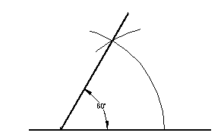

*Figure 6.2* To construct 600

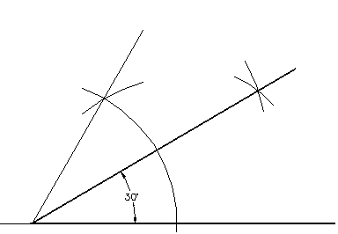

*Figure 6.3* To construct 300

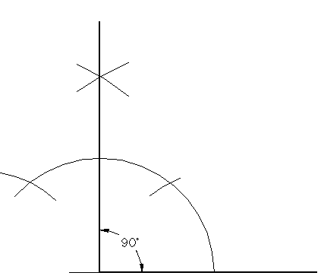

*Figure 6.4* To construct 900

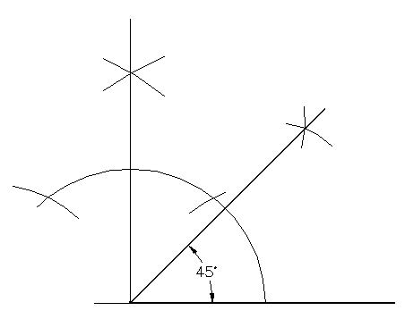

*Figure 6.5* To construct 450

**To divide a line into a number of equal parts**

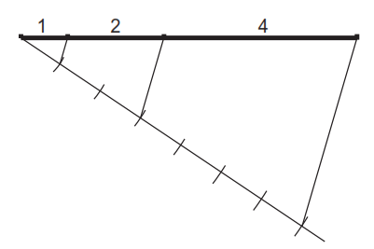

*Figure 6.6* To divide a line proportionally (1:2:4).

# **6.1 THE TRIANGLE**

The triangle is a plane figure bonded by three straight sides.

**Parts of Triangle**

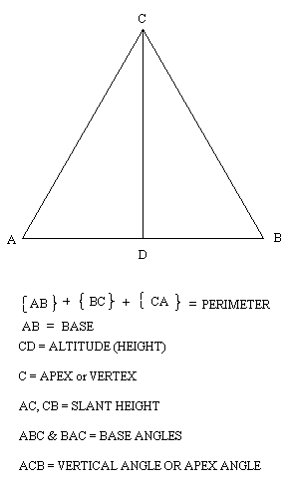

**TYPES OF TRIANGLE**

A *scalene* triangle is a triangle with three unequal sides and three unequal angles.

An *Isosceles* triangle is a triangle with two sides, and hence two angles, equal.

An *equilateral* triangle is a triangle with all the sides and hence all the angles, equal.

A *right angle* is a triangle containing one right angle. The side opposite the –angle is called the hypotenuse.

**To construct an *equilateral* triangle given one of the sides**

1. Draw a line AB, equal to the length of the side.
2. With compass point on A and radius AB, draw an arc as shown.
3. With compass point on B, and with the same radius draw another arc to cut the first arc at C
4. Triangle **ABC** is equilateral.

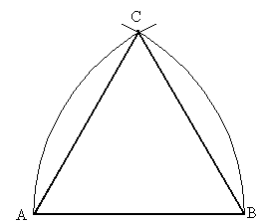

*Fig. 6.1.1*

**To construct a triangle, given the base angles and the altitude**

1. Draw a line AB

2. Construct CE parallel to AB so that the distance between them is equal to the altitude.

3. From any point D, on CE, draw angle CDF and angle EDG so that they cut AB in F and G, respectively

Since angle CDF = DFG and angle EDG = DGF (alternate angles) then DFG is the required triangle.

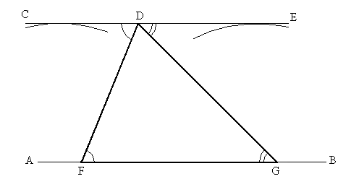

*Fig. 6.1.2*

**To construct a triangle given the perimeter and the ratio of the sides**

1. Draw the line AB equal in length to the perimeter

2. Divide AB into the required ratio (e.g. 4:3:6)

3. With centre C and radius CA, draw an arc.

4. With centre D and radius DB, draw an arc to intersect the first arc in E.

ECD is the required triangle.

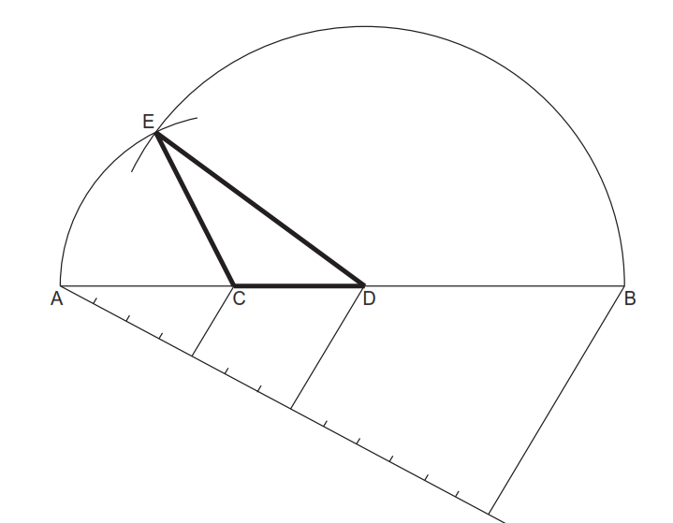

*Fig. 6.1.3*

**Exercise 1**

1. Construct an equilateral triangle with sides 60 mm long
2. Construct a triangle with base angles 600 and 450 and an altitude of 76 mm
3. Construct a triangle with a perimeter measuring 160 mm and sides in ratio 3:5:6



